#include <Servo.h>
#include <LiquidCrystal.h>

LiquidCrystal lcd(12, 11, 5, 4, 3, 2);
Servo myservo;

#define ServoM 7
#define Exit 9
#define In 8
#define Pwr 6
#define Gnd 10
#define BarLow 90
#define BarUp 177
#define CAPACITY 24

int Available = 24;

void setup()
{
myservo.attach(ServoM);
lcd.begin(16, 2);
lcd.print(" BatStateU Parking!");

pinMode(Gnd, OUTPUT);
pinMode(Pwr, OUTPUT);
pinMode(Exit, INPUT);
pinMode(In, INPUT);

digitalWrite(Gnd, LOW);
digitalWrite(Pwr, HIGH);

myservo.write(BarLow);
delay(1000);
}

void loop()
{
if (Available == 1)
{
lcd.clear();
lcd.setCursor(1, 0);
lcd.print("Space left for");
lcd.setCursor(0, 1);
lcd.print(Available);
lcd.print(" car");
delay(1000);
}
else
{
if (Available >= 1)
{
lcd.clear();
lcd.setCursor(1, 0);
lcd.print("Space left for");
lcd.setCursor(0, 1);
lcd.print(Available);
lcd.print(" cars");
}
else
{
lcd.clear();
lcd.setCursor(1, 0);
lcd.print(" Sorry!");
lcd.setCursor(0, 1);
lcd.print(" No Place left!");
delay(1000);
}
}

if (digitalRead(In))
{
if (Available != 0)
{
Available--;
myservo.write(BarUp);
delay(3000);
myservo.write(BarLow);
}
}

if (digitalRead(Exit))
{
if (Available != CAPACITY)
{
Available++;
myservo.write(BarUp);
delay(3000);
myservo.write(BarLow);
}
}

delay(80);
}

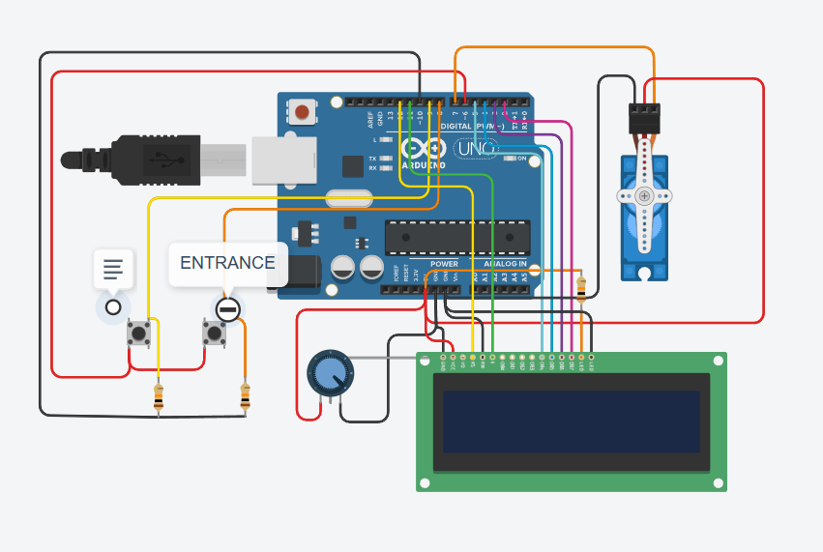

https://www.tinkercad.com/things/ezecDAE5xwy-car-parking-system?sharecode=t4oeomfR8LsG0Th0rDcN3I_Cw5Pc7IqjE1EFeb50IdE

